Resume of Abdul Gaffer Forhad
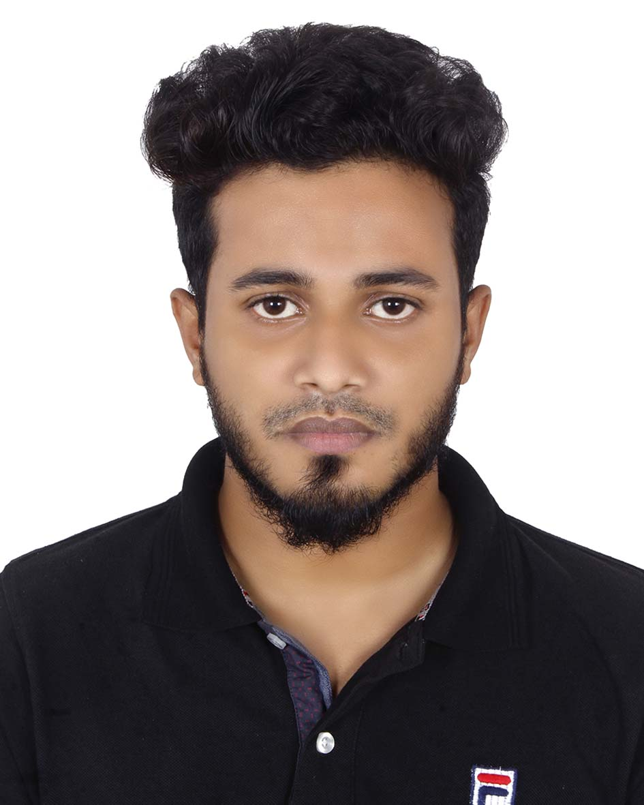
ABDUL GAFFER FORHAD
Address :House-15/6,Ward-09,Block-B,Road-05, Khilbarirtek, Dhaka 1212, Vatara, Dhaka
Mobile :01787151950
e-mail: abdulgaffer1100@gmail.com

Career Summary

I have been working in marketing for last one years and five months. I am now also ready to pursue a challenging career in a renowned and fast growing Organization, in the field of Service Management with a view to utilize my knowledge & skills for the progress and growth of the organization. I would like to build up my career in this particular area as well as conquer new opportunity to gather knowledge, experience and proficiency.
.
Key responsibilities

- Work with and expand current prospect database within specified business sectors to
generate effective leads & exceed sales targets for the business.
- Develop a sales contact plan direct marketing, and attending industry events to build
relationships with key prospects.
- Work closely with colleagues in Tradedoubler to identify common new business prospects
and cross-sell integrated search and affiliate proposition.
- Work closely with marketing to identify appropriate go to market messaging for specific
business sectors.

DETAILED PROFESSIONAL EXPERIENCE

- Bizcom Limited (1st March, 2018 – continue)
- Major responsibilities as “Sales Executive, ”

- Achieve and exceed the allocated sales target.
- Deliver the highest levels of customer service, thereby creating customer loyalty and repeat sales.
- Ability to problem-solves and ultimately delivers sales results within set timeframes.
- Maintaining relationship with all potential and existing clients.
- Ensuring proper servicing and after sales support to clients.
- Data reporting to management and gathering market intelligence.

Academic Qualifications

Exam Title | Subject | Institute | CGPA | Year
BBA | Business Studies | Manarat International University | Appeared | 2020
H.S.C | Commerce | Milestone College | 4.80 out of 5 | 2014
S.S.C | Commerce | Milestone College | 4.08 out of 5 | 2012

Computer Proficiency

- Operating System : Windows ( Windows 7, Windows 10)
- Office Management : Microsoft office 2003-2010 (MS Word, MS PowerPoint)
- Internet : Browsing (Friendly with Any Browsing Software)
- Operating System : Windows (Windows 7, Windows 10)
- Office Management : Microsoft office 2003-2010 (MS Word, MS PowerPoint)

Languages

- Bengali (verbal and written)
- English (verbal and written)

Hobbies &Interests

- Reading, watching movies, music & art.
- Gardening

Personal Details
Father's Name | : | A.N.M Edris
Mother's Name | : | Hasina Edris
Date of Birth | : | April 14, 1997
Gender | : | Male
Marital Status | : | Unmarried
Nationality | : | Bangladeshi
Religion | : | Islam
Permanent Address | : | Moulabiabdul Rashid Saheber Bari,Word-5,Charkakra, Companiganj, Noakhali

Reference (s)

Name | : | Mohammad Zohidul islam
Organization | : | Kallol Group of Companies
Designation | : | Manager Commercial and Logistics
Address | : | shajadpur Dhaka 1212
Phone (Off.) | : | 880288160049
Phone (Res.) | :
Mobile | : | 01678007449
E-Mail | : | zohir@kallolgroup.com
Relation | : | Relative

I certified that all of my information and source is very true of my best of my knowledge.

Signature : Abdul Gaffer Forhad
Date : 31/08/2019

